### [A Paper Baby Carriage For a Baby Shower](https://papercraftetc.blogspot.com/2018/08/a-paper-baby-carriage-for-baby-shower.html)

This baby carriage has wheels that work because there is an axle built into the design. I made fifteen of these baby carriages for a baby shower. They are a labor of love because they take about an hour a piece to make. I hope the recipient loves them as they are on their way to France for a baby girl shower.

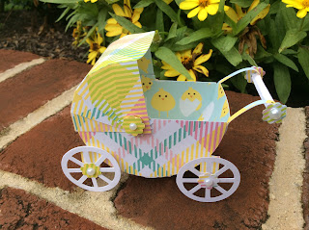

I used cardstock for the model, two brass plated fasteners(brads) and glue on pearls for the embellishments.

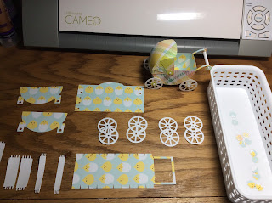

There are a lot of pieces. Separate them on a table. There are eight wheels. Align and glue two together to make four sturdy wheels.

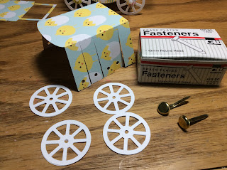

Bend each canopy side inward. I cut the ends of a brass plated fastener to about a half inch length.

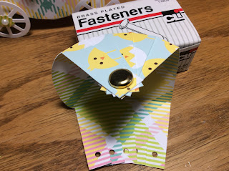

Align the circles together and insert the fastener. Do not close the fastener yet. Repeat for the other side.

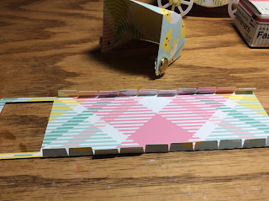

Bend the tabs of the carriage upward.

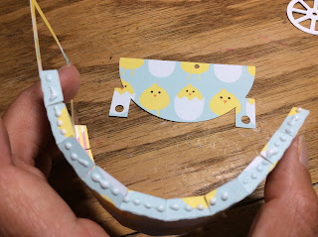

Gently, bend the carriage into a U shape.

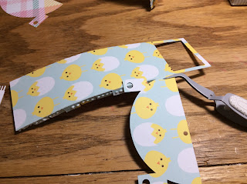

Apply glue to the tabs on one side. The hole on the side is closer to the back of the carriage. Make sure it is correct before you glue the side. I like to use tweezers to hold one end and then I align the other top end. The U shape is easy to adjust once the two top ends are aligned.

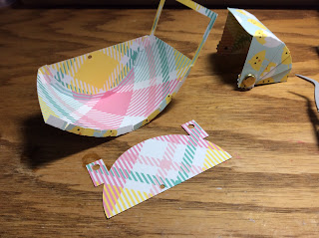

Repeat for the other side.

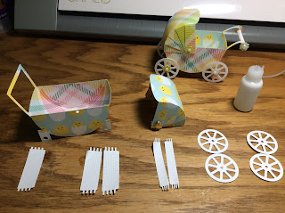

Arrange the axle and handle pieces. The handle piece has the shortest tabs. The white piece on the left is the handle.

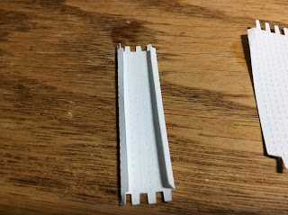

Fold the ends down and then curve the piece to make a tube.

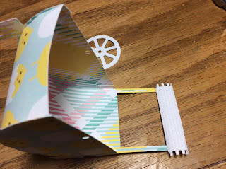

Glue the handle to one side of the main handle.

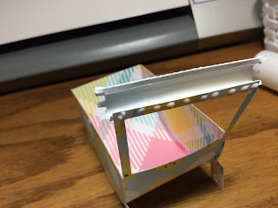

Roll into a tube and glue the other side.

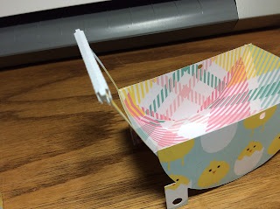

Rolled handle.

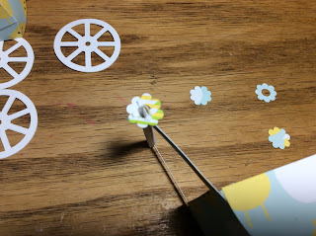

Slide on the flower with the largest hole in the middle onto the tabs. Glue down the four tabs.

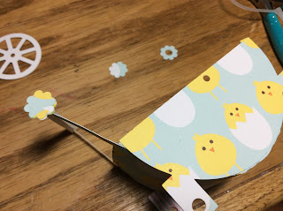

Glue on a flower to complete the handle on one side.

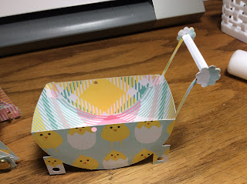

Repeat for the other side.

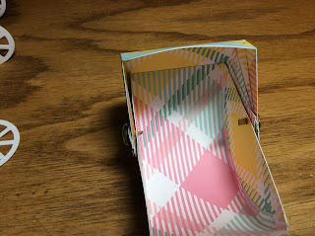

Attach the canopy by inserting the fastener in the hole on the side of the carriage.

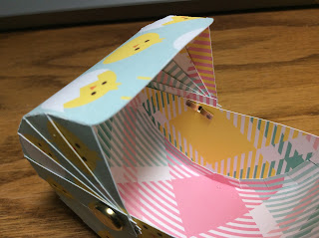

Repeat for the other side and close the fastener on both sides.

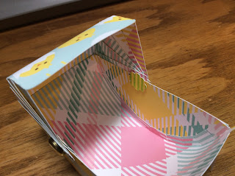

Glue a flower over the fasteners to hide them from view.

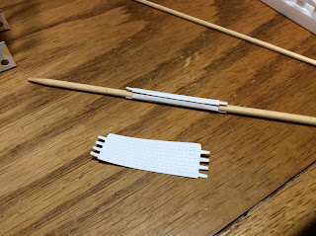

Roll the wide axle around a wooden skewer and glue into a tube. Repeat for the other axle.

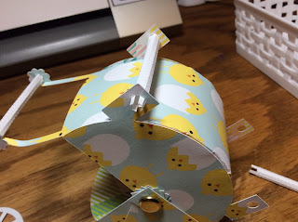

Insert the wide axle into the holes at the bottom of the carriage on each side.

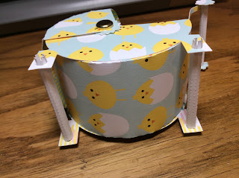

Repeat for the other axle.

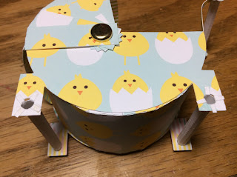

Bend the tabs down and glue all the tabs down.

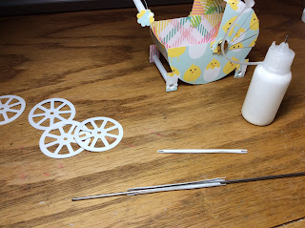

Roll the narrow axle into a tube. Repeat for the second axle. It helps if you can find a small toothpick or wire to wrap it around and glue it.

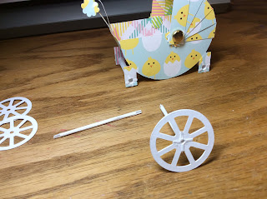

Attach the axle to one of the wheels and glue the tabs down.

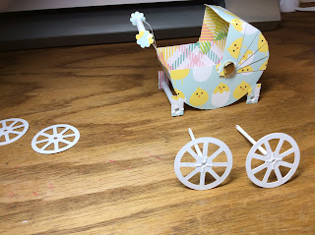

Repeat this for the other axle.

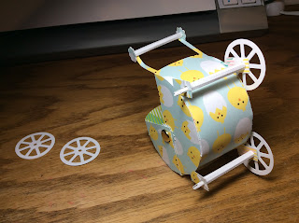

Insert the small axle into the big axle piece.

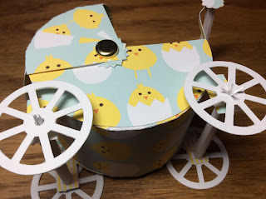

Attach a wheel to each small axle. Glue the tabs down on each wheel.

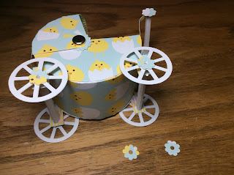

Glue the flower with the small hole to each of the axles.

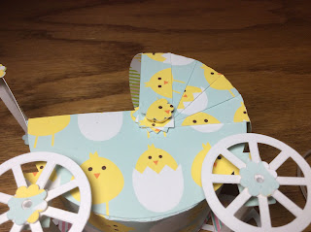

Glue a flower on the brass fastener by the canopy.

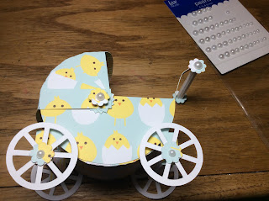

Add pearl embellishments.

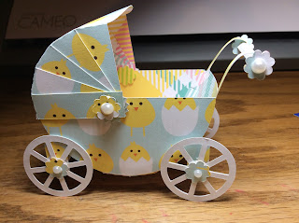

I curled the handle a little by twirling the handle downward.